**Launch Endpoint Maintenance**

In order for the Application Availability Monitor to run successfully, there are a few maintenance items that we suggest reviewing.

**LogonSimulator.exe**

This process must always be running on the Launch Endpoint in order for the GAAM launches to take place. Upon configuration of the launch endpoint, this process was put into the startup folder for the user who ran GAAMEndpoint.exe. With that said, this user is now tied to the LogonSimulator.exe process and must always be signed into the Launch Endpoint in either an Active or Disconnected session (not locked).

**Google Chrome**

Please note, there are a few of settings that are saved within the browser cache. If the browser cache for Google Chrome is cleared on the launch endpoint it is likely that subsequent launches will fail post cache clearing. To resolve, please repeat the steps in the Launch Preparation section of the [Launch Endpoint Installation & Configuration](https://support.goliathtechnologies.com/hc/en-us/articles/360024769993) article.

Also, prior to GAAM schedules taking place on the GAAM Launch Endpoint, any open Google Chrome sessions will be exited. Please use an alternate web browser, ie Microsoft Edge, when needing to have a web browser open during a GAAM launch.

**Reboot Schedule**

Depending on how frequently your launches are scheduled to take place, Goliath suggests implementing a reboot schedule on your launch endpoint to ensure optimal success. For launches taking place every 5-15 mins nightly reboots are suggested. For launches taking place every 30 mins to an hour or more, weekly reboots are suggested. Prior to configuring the reboot schedule, ensure that automatic windows logons are configured for your local endpoint user (the user running logonsimulator.exe as described above).

**Screenshot Feature**

When viewing the GAAM results within the Goliath web console, Goliath has the ability to take screenshots of the launches in action and display them with the launch results. In order to enable the screenshot functionality, **an active console session** for the local endpoint user is required. If screenshots are not enabled the product will still work and report as expected, just minus the screenshots.

**Examples of how to achieve an active console sessions**:

1. Hypervisor Console:
   * Connect to your hypervisor that hosts the launch endpoint (if it is a VM)
   * Launch a console session to the launch endpoint as the local endpoint user
     + This is the user account that is configured to run LogonSimulator.exe process
   * Using Control Panel>Power Options, ensure that the display will never turn off and the computer will never be put to sleep
   * Exit all open programs and close the console session
   * The console session must always exist in order for the screenshots to capture
2. Double hop RDP session:
   * RDP into any server in the environment with a user that will always be in an active or disconnected state
   * From the above RDP session, RDP to the launch endpoint as the local endpoint user
   * Using Control Panel>Power Options, ensure that the display will never turn off and the computer will never be put to sleep
   * Exit all open programs
   * minimize the launch endpoint RDP session
   * Disconnect from the original RDP session

**Screenshot feature examples:**

Screenshots enabled:

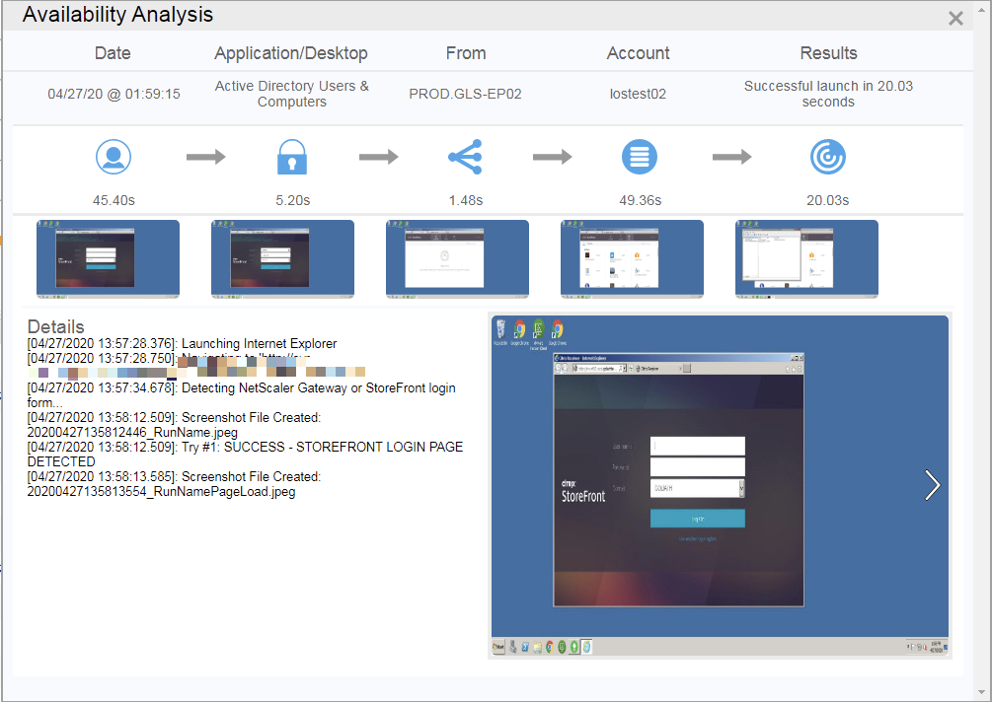

Screenshots disabled:

